Technical challenge: Sentence to emoji

As this is a busy period for me, I was not able to complete all the requirements of the assignment, but this is what I managed to do:
Because the preferred programming language was Python, and due to its elegance and simplicity and flexibility, I used Flask to develop this application.
To make the RESTful API easier to use, I have developed a very simple web application that uses this API. To start both application, the “startApp” bash script should be run, after the prerequisites are installed. The web application will start at http://127.0.0.1:5001/.

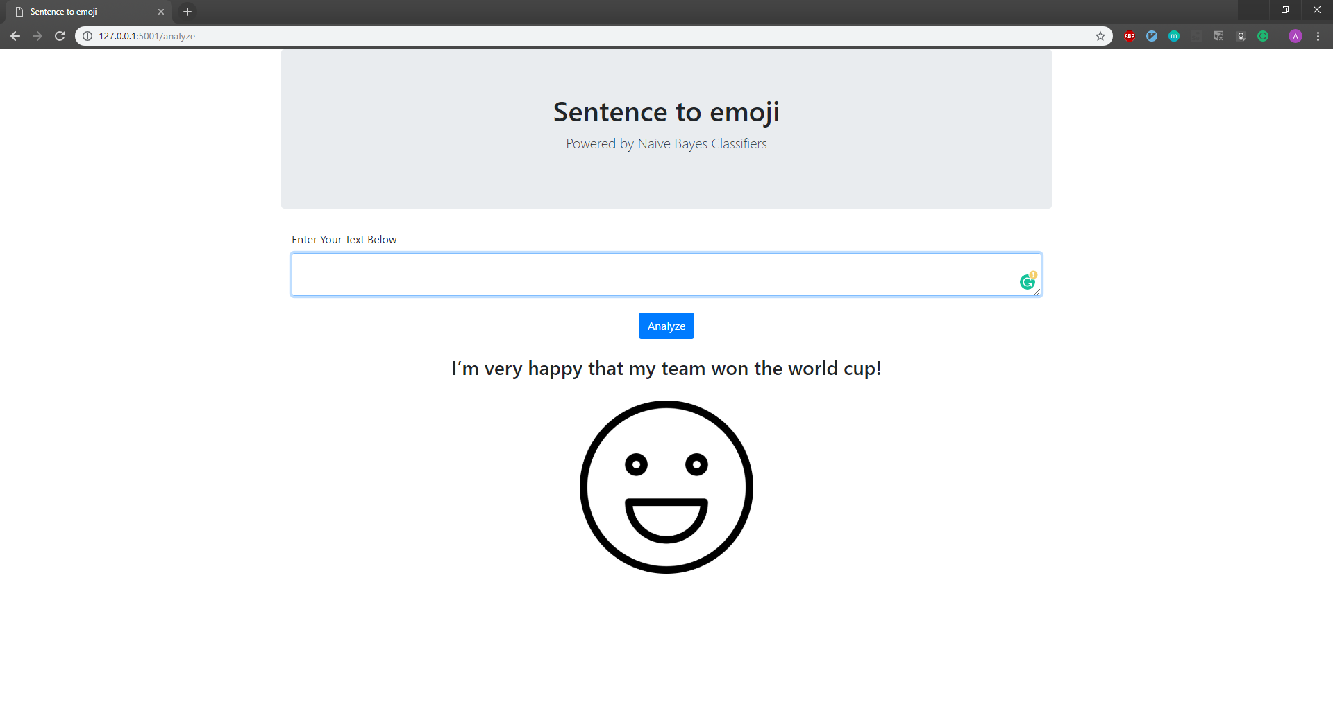

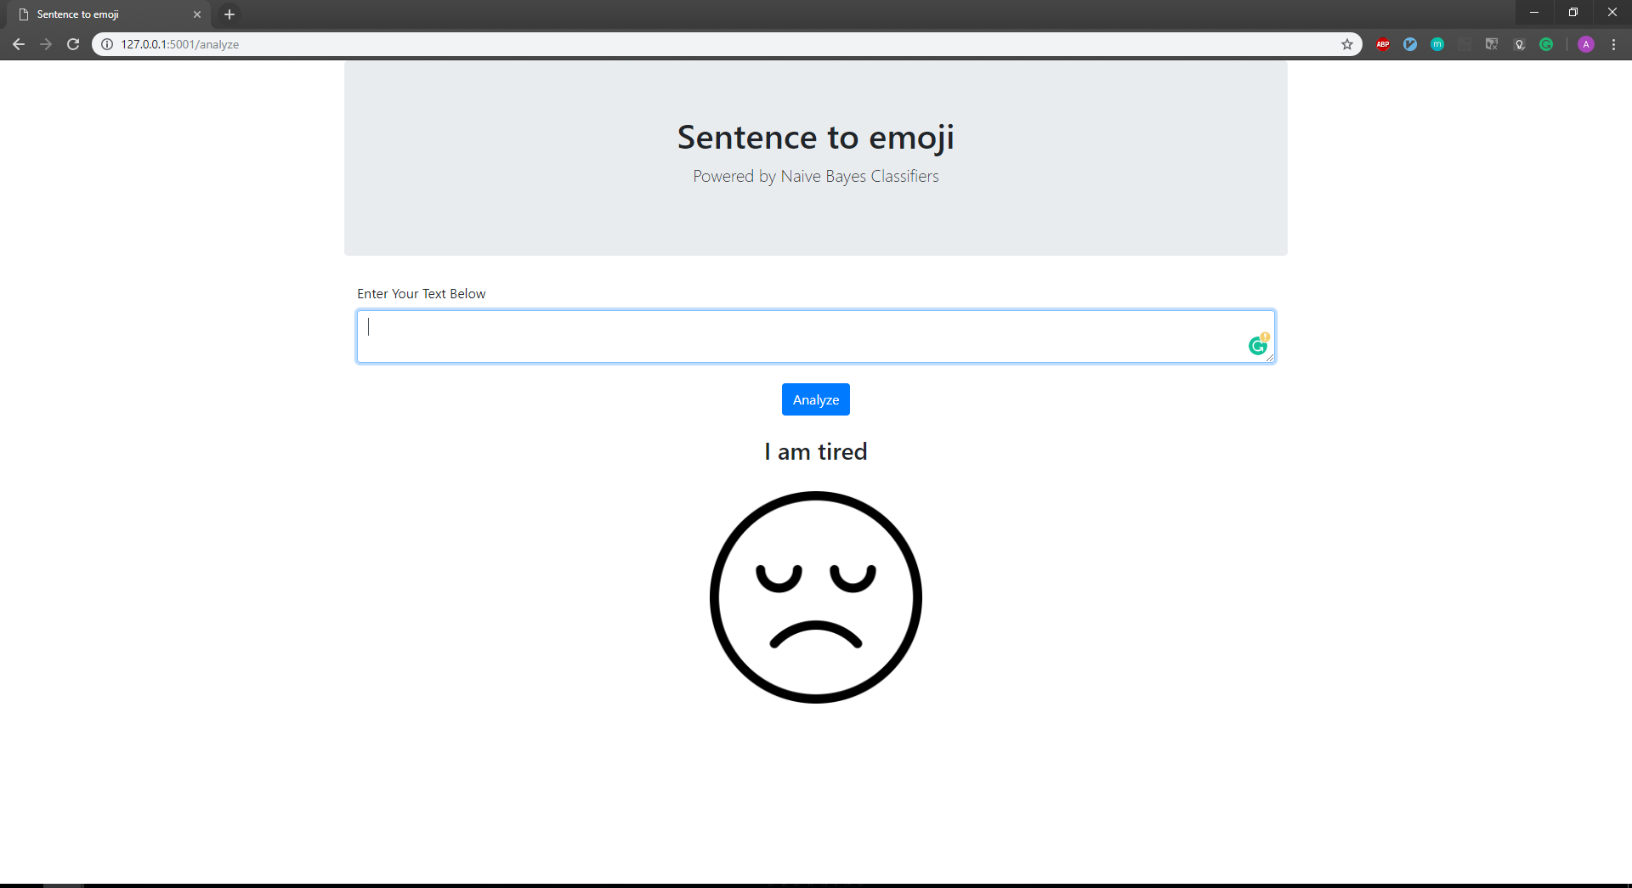

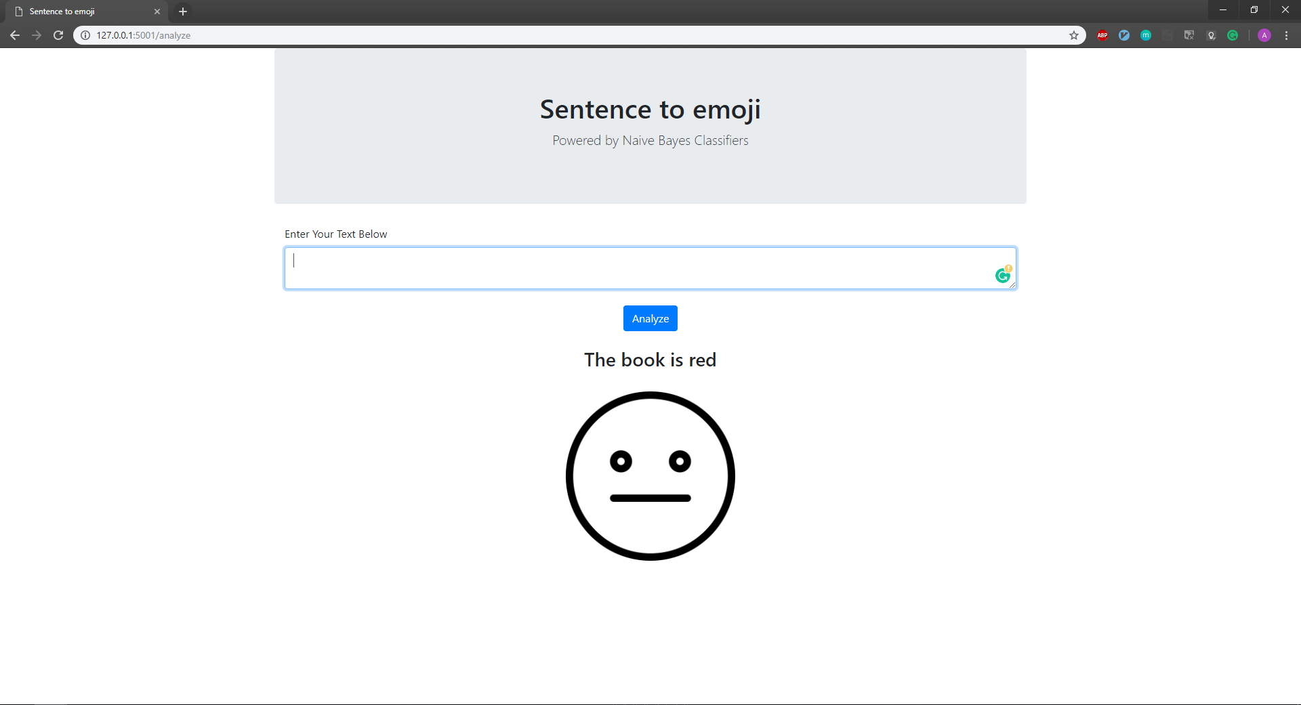

The RESTful API uses the TextBlob, a library for processing textual data. Using this library, I was able to access the polarity score of the text. The polarity is calculated using a NaiveBayes classifier, trained with a dataset of movie reviews. In addition, because one of the theoretical questions was related to the support for multiple languages, I have used functionality provided by this library to detect the language of the text, and translate it English. The functionality of this library is powered by Google Translate API.

Additional points:

A user can tell the service what their favourite emoji is. After that, when the user asks what their favourite emoji is, the service will reply to that specific user with their favourite emoji.
Answer:
To add support for this functionality, if we have enough “text->intent” data, LSTM networks can be used for intent analysis. If not, a rule-based system, with manually crafted rules, can be used.
To detect the emoji, more details about the functional specifications are required, as the emojis can be encoded in only one character and in a combination of a couple of them (e.g. :D), or a longer combination of a vertical nature ( e.g. ¯ \ _ (ツ) _ / ¯ ) . This comprehensive list: https://unicode.org/emoji/charts/full-emoji-list.html can be a good start to decide what will be the supported emojis, and what validation should be made for the emojis that are not supported.

Theoretical questions:

- How does your system scale to thousands of concurrent users and how would you improve scalability?
The system is sending only the data that will be used by the client, saving bandwidth and response time.
In my current implementation of the API, there is no need for asynchronous code, as the number of operations that are performed on the data is very small, and the operations have to be serial.
Another possibility to scale the system, beside the vertical scalability, would be to horizontal scalability, putting the server behind a reverse proxy server, balancing the load between the servers.
- Imagine you had to support many different languages, how would you design your system to do that?
Multiple endpoints, based on the language, can be added.
- If you had to train your own model, how would you go about that? Describe what kind of model and data you would use.
The first thing that I would do would be to frame the problem. To do this, I would have to ask for more details about the functional specifications: how many categories should be predicted, or what is the minimum accuracy. Based on the received information, I would start to explore all the possible options, starting with a rule based system, using the classic NLP techniques like stemming, tokenization, part of the speech tagging and parsing, continuing with lexicons, and finishing with machine learning techniques ( like Naïve Bayes or RNNs ). After testing all this models, I would implement a hybrid system from the models with the best results.

Feedback is greatly appreciated.
Thank you,
Adrian Pintilie

